S3 TASK-01

1. Create an S3 bucket and upload some objects to S3.

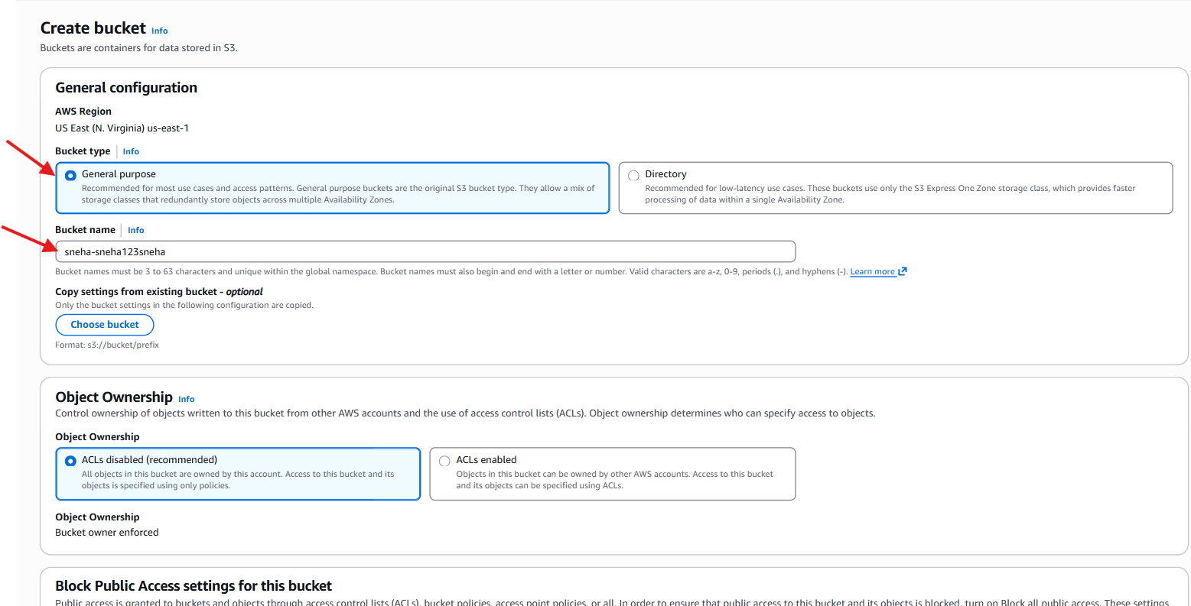

Successful bucket is created

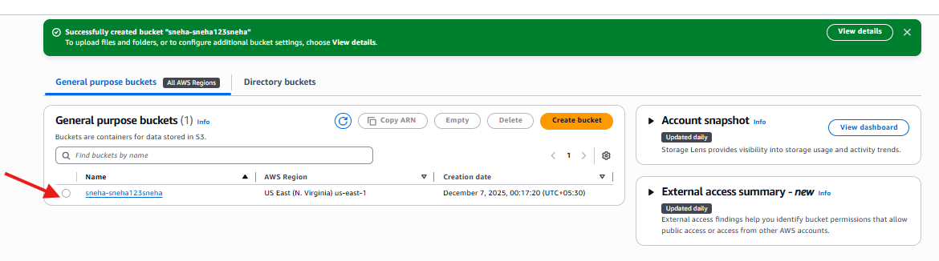

Hear you can upload the file

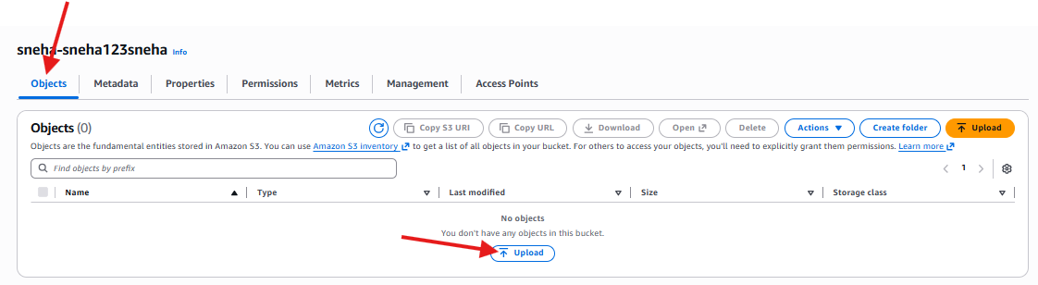

Hear you can add the file

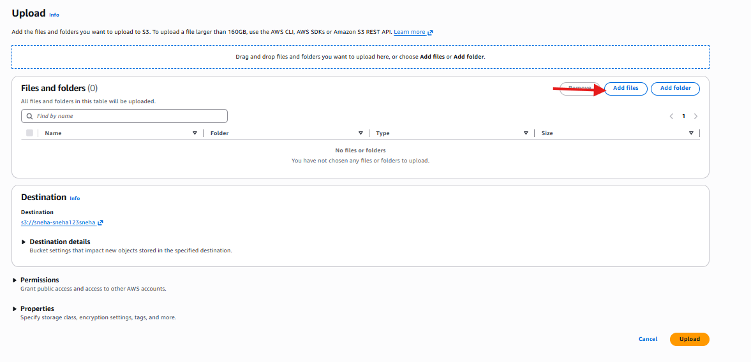

Added the file and uploaded

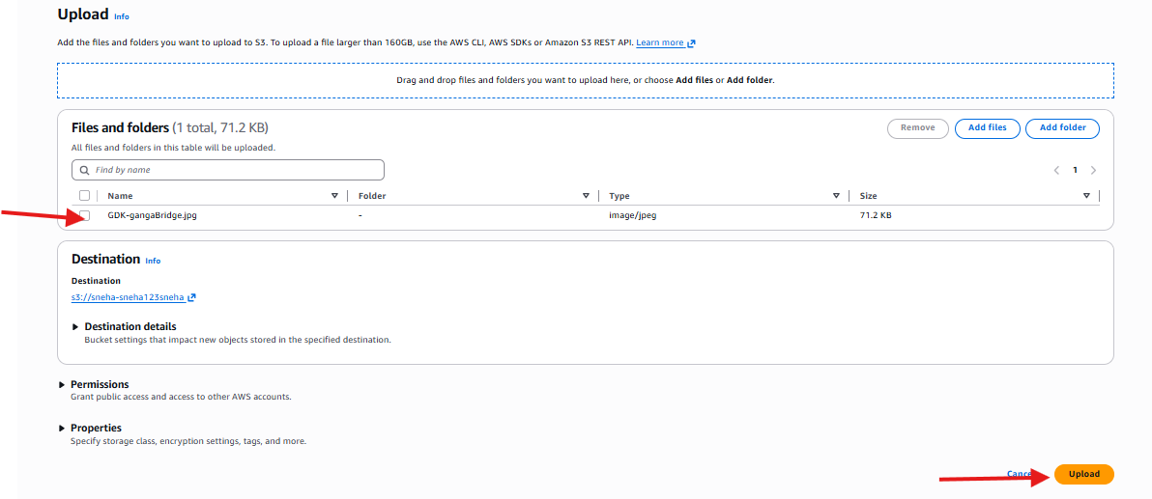

Go to the object overview

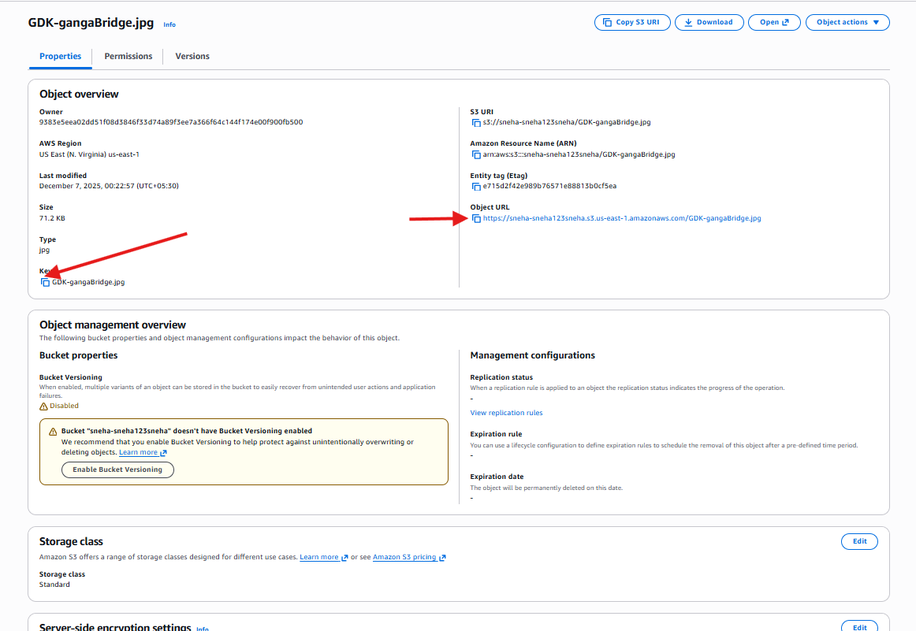

It’s getting error with xml format

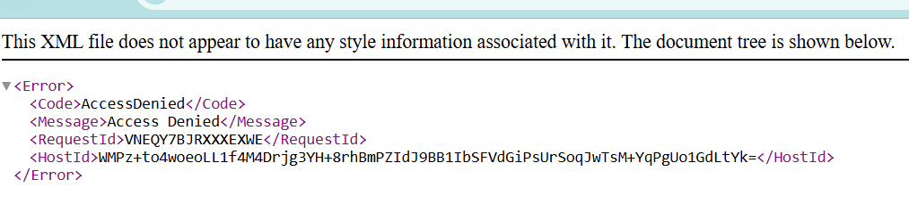

Go to the permissions and enable 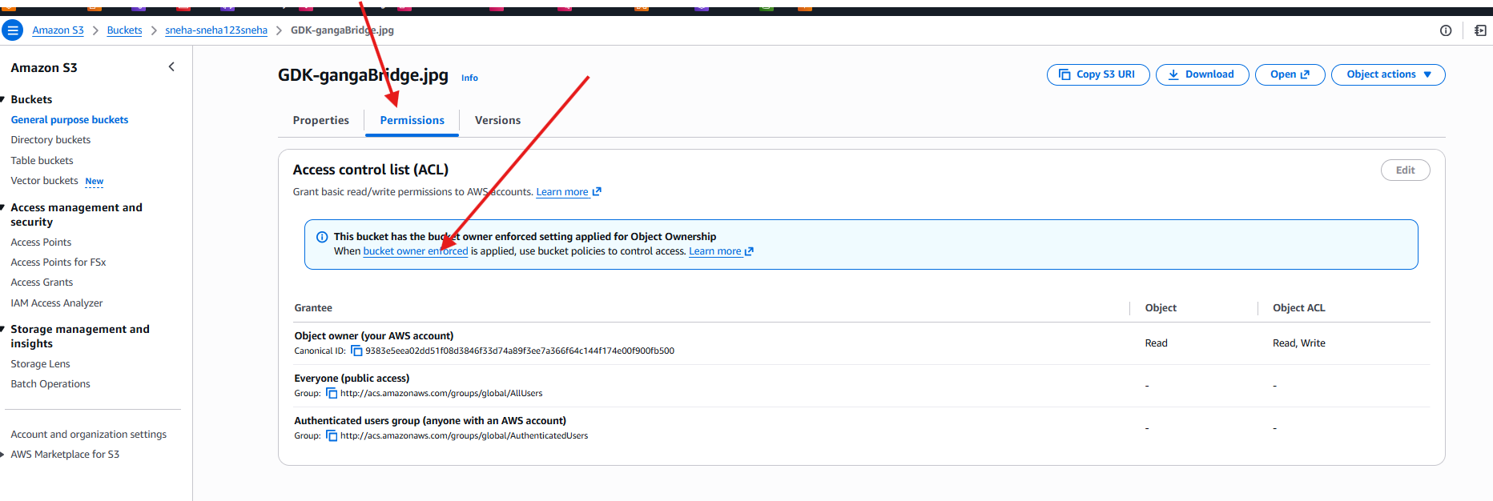

ACL enable

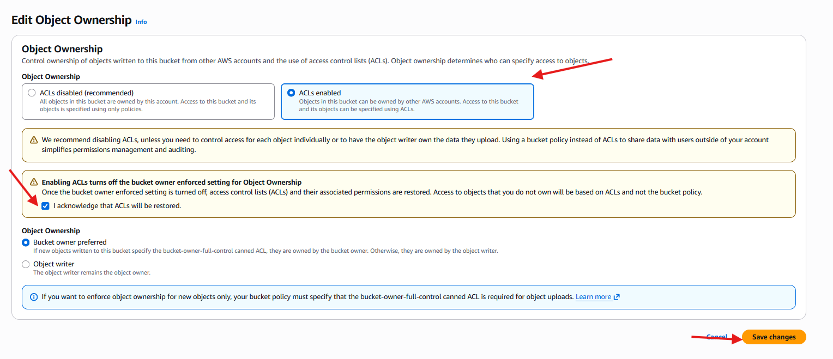

Go to the edits

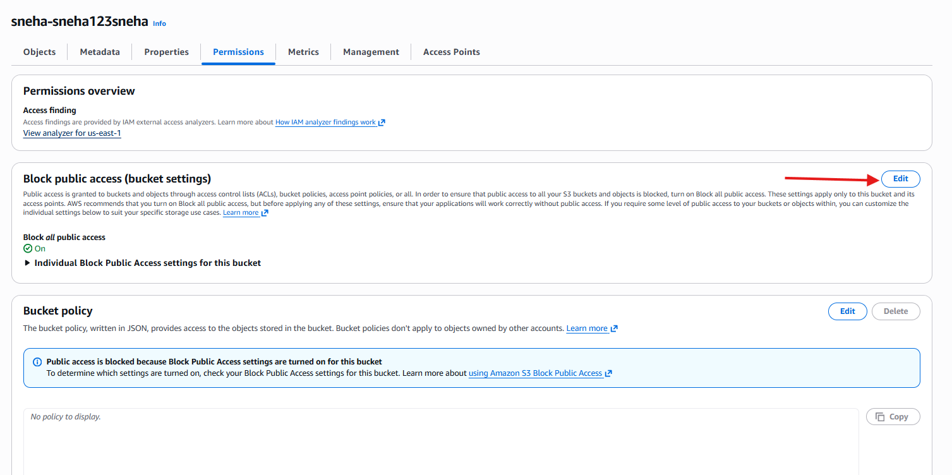

Enable public access

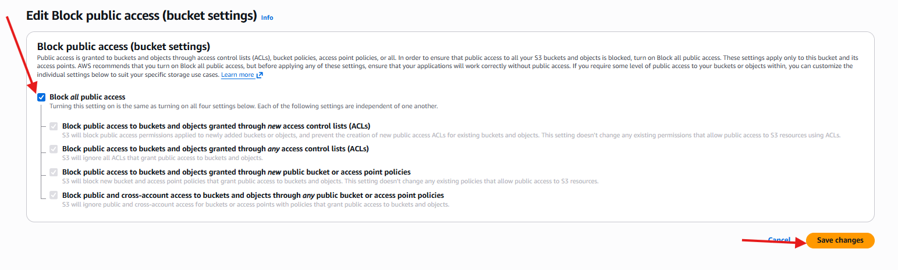

Confirm

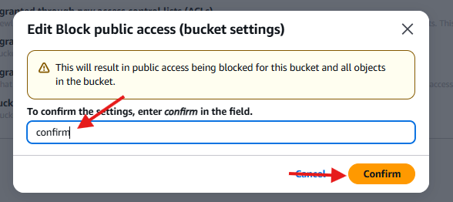

Go to the objects select the file and go to the actions and make public using ACL

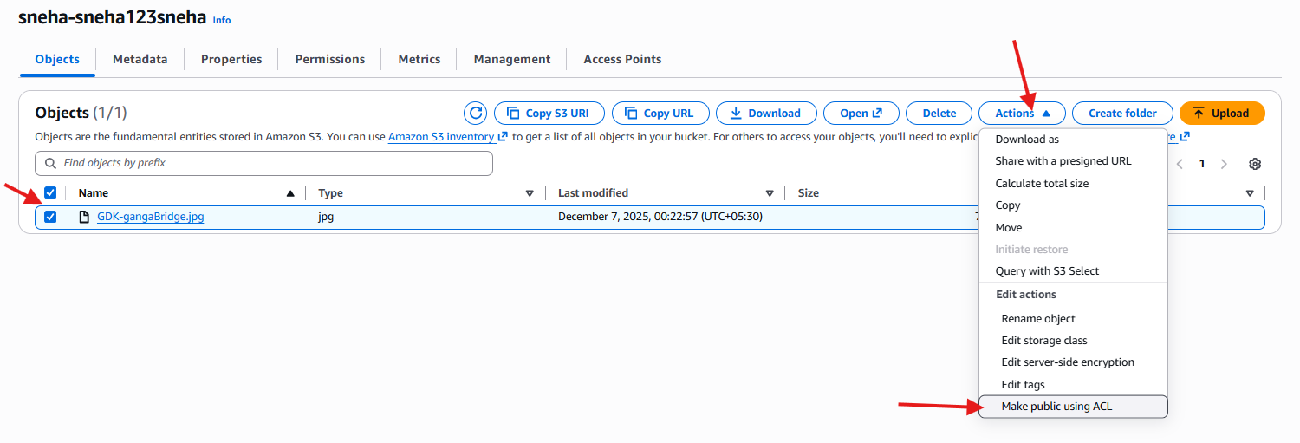

Make it public

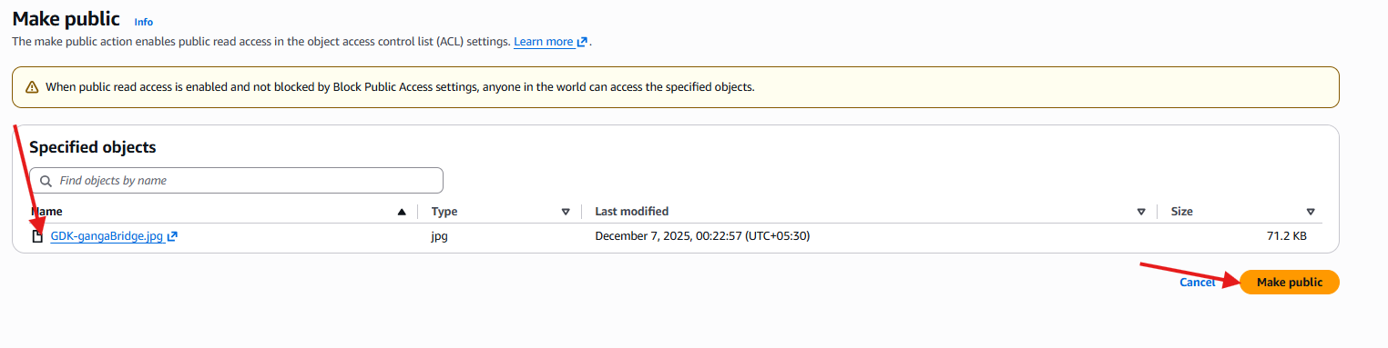

Select the URL

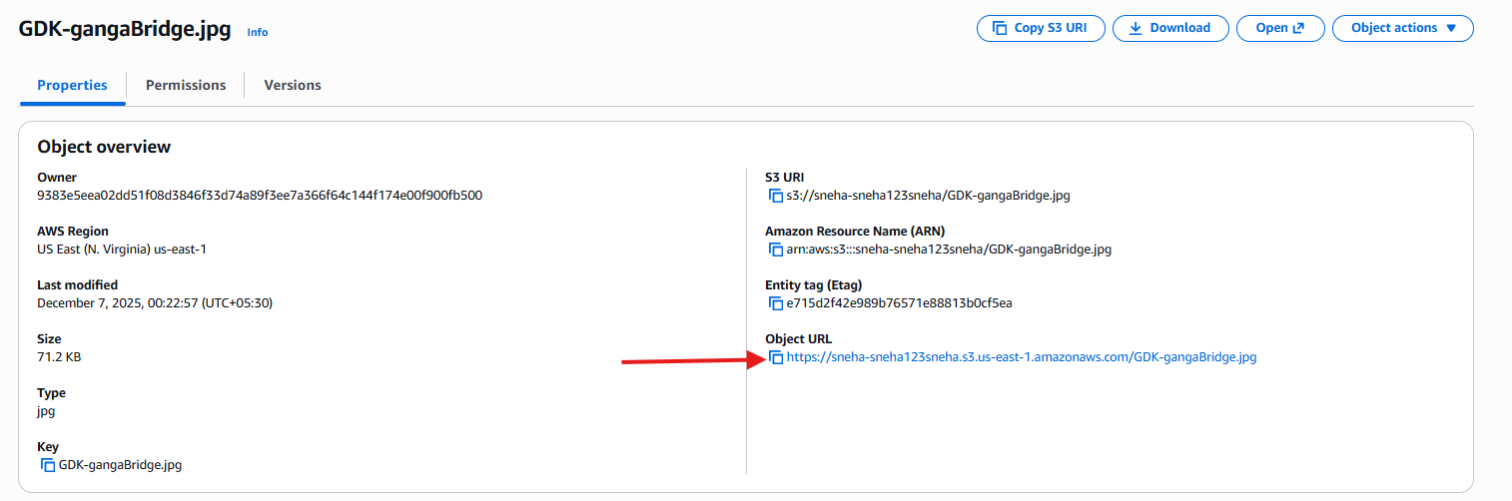

This is my S3 buck URL

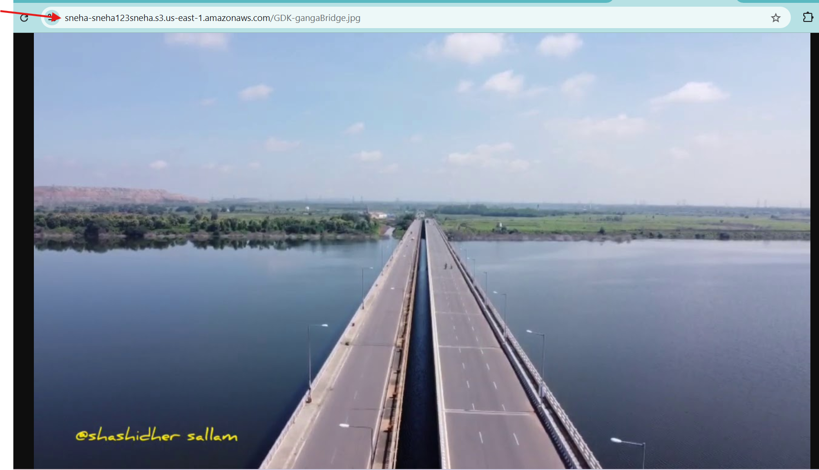

1. Deploy a static website in the S3 bucket.

Create one S3 bucket

Upload the file

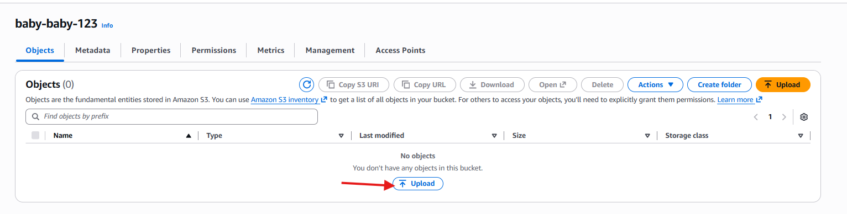

Upload a files and folder

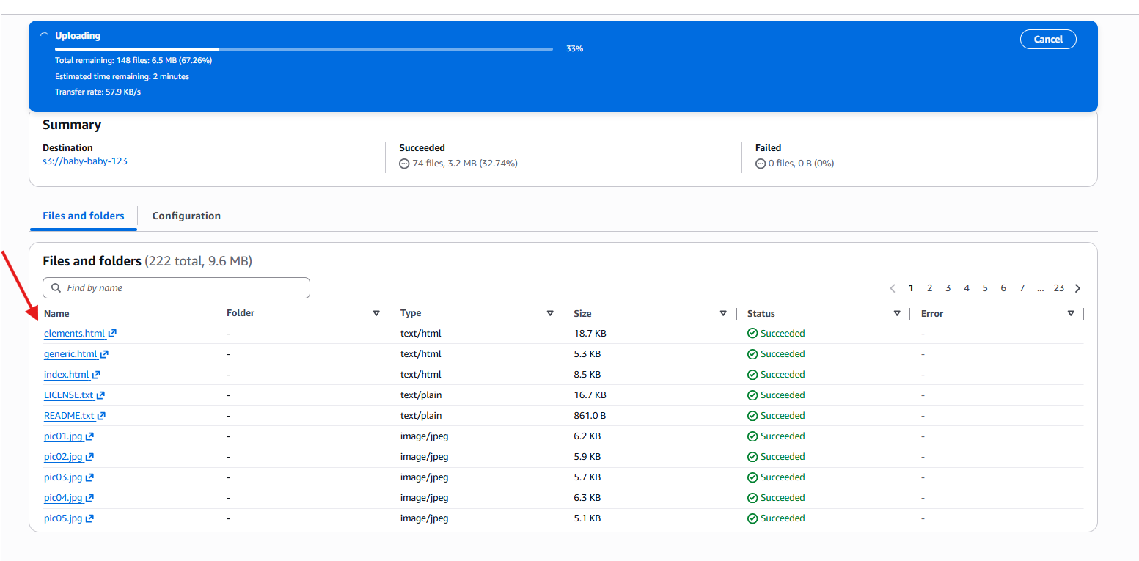

Objects has been uploaded successfully

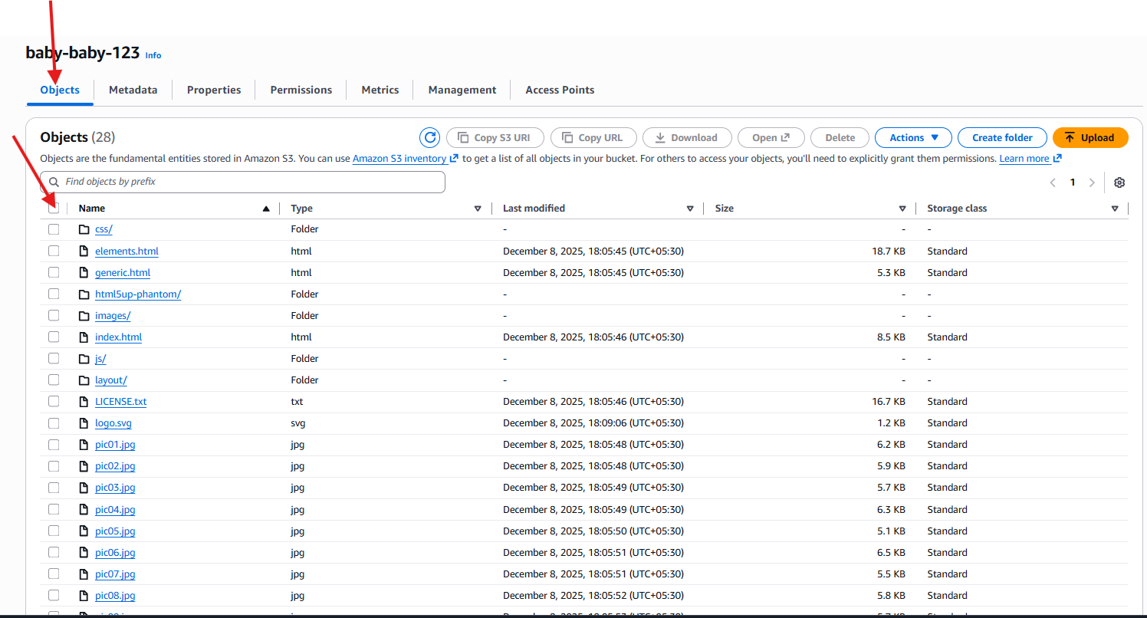

Give the permissions

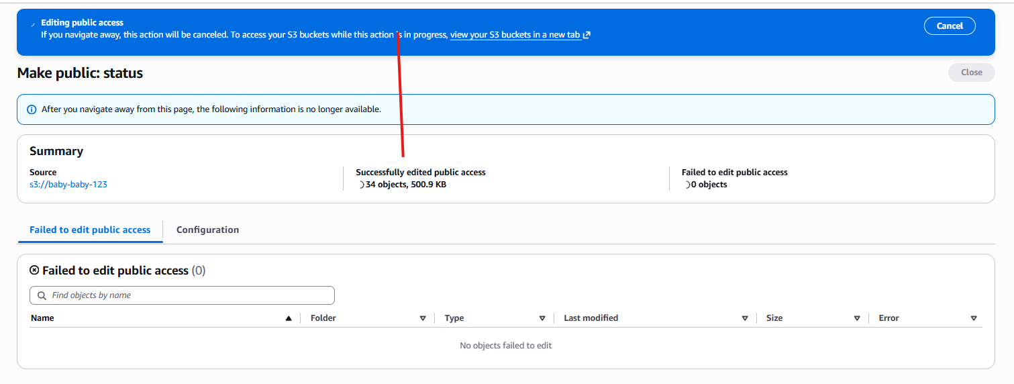

Give the public access

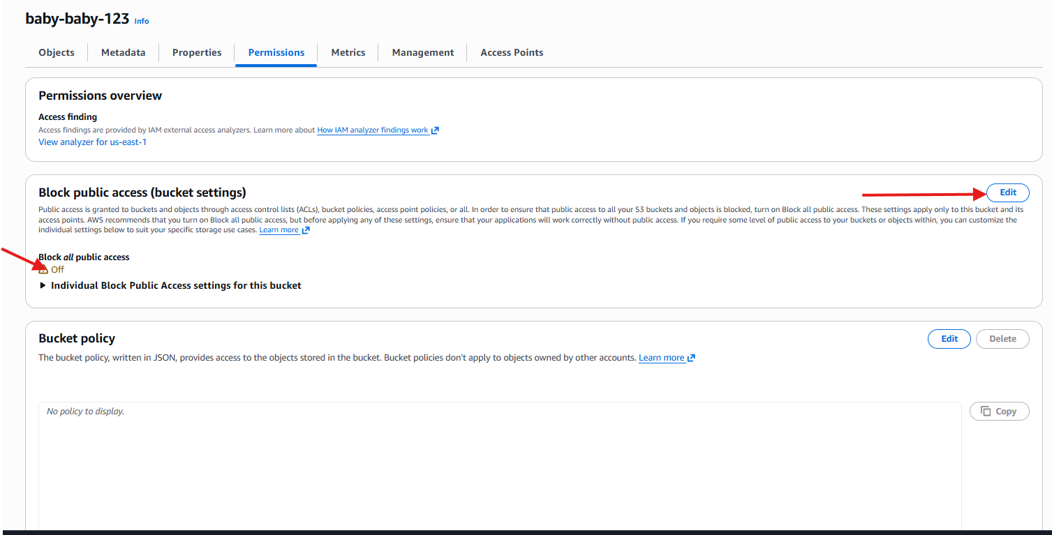

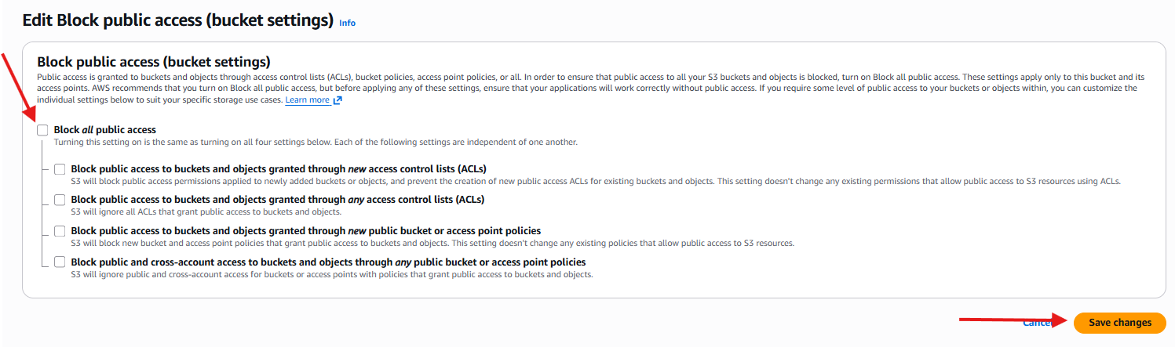

Confirm

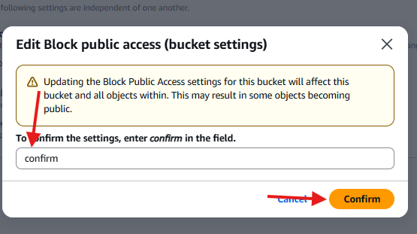

Go to the properties there is a statice website

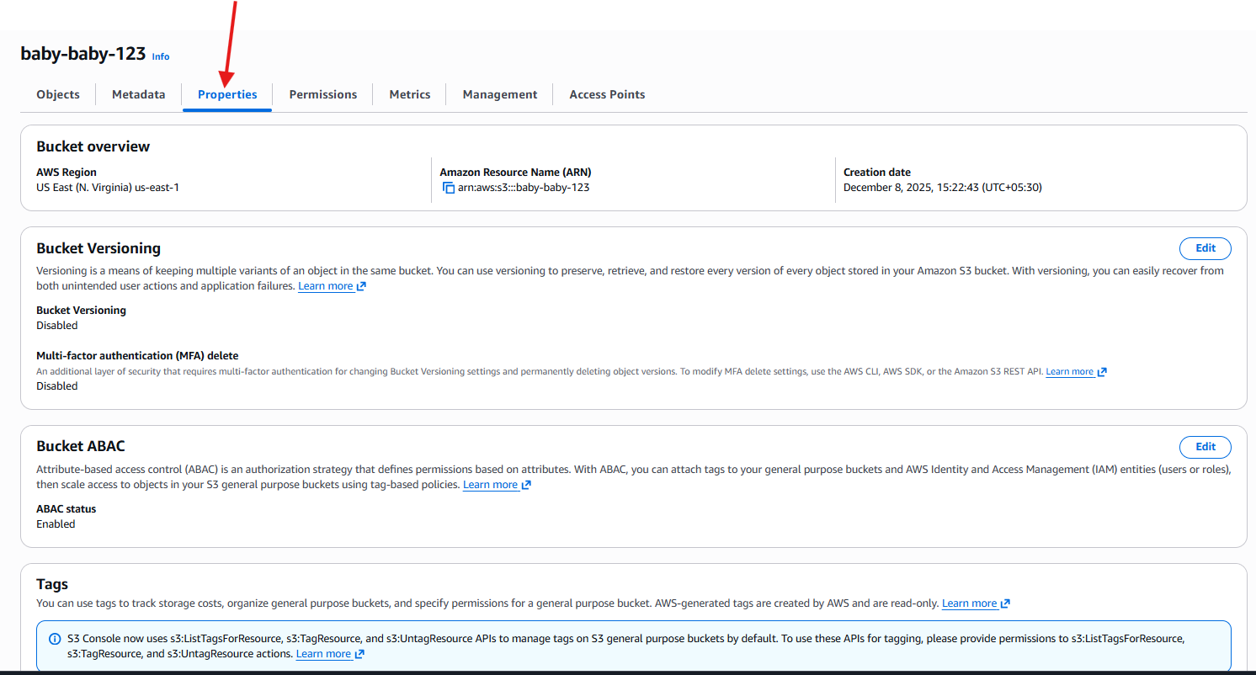

Static website host edit it

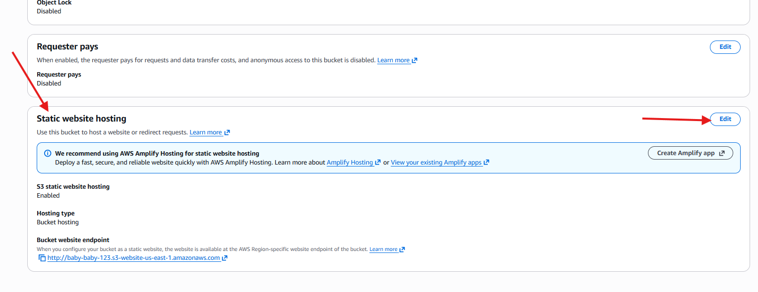

Hear it is showing disable then we can enable it

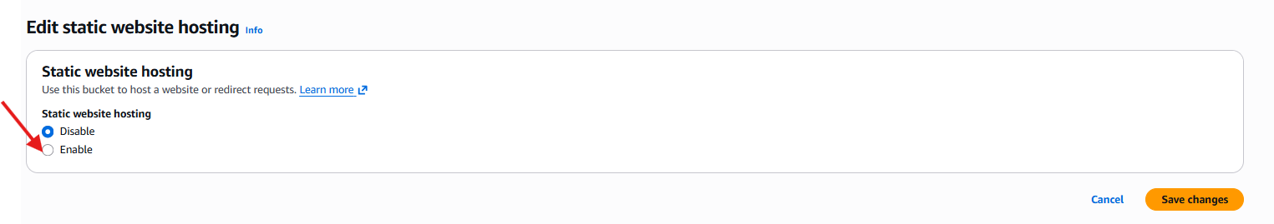

Don’t change enaything but index document should be name as index.html

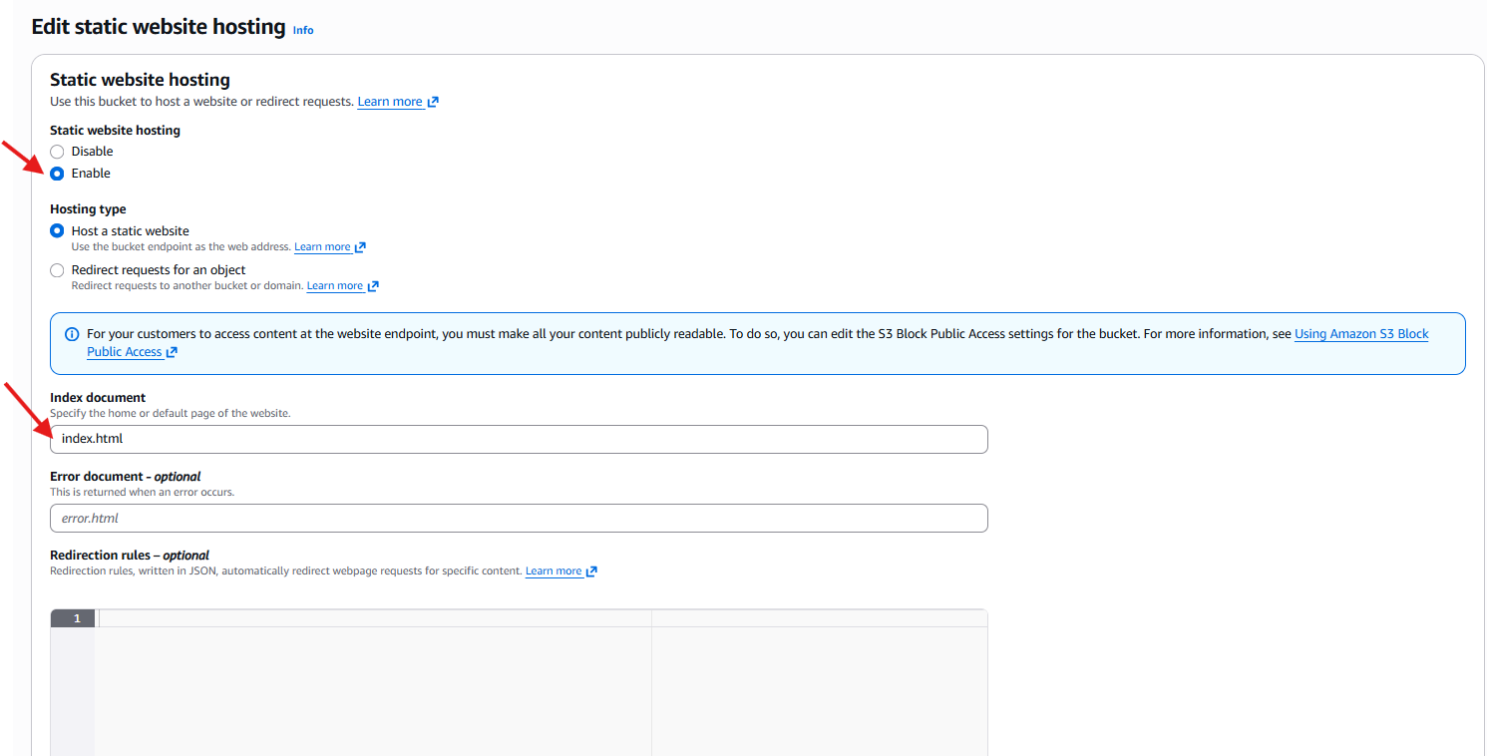

Then static website will give the bucket static URL

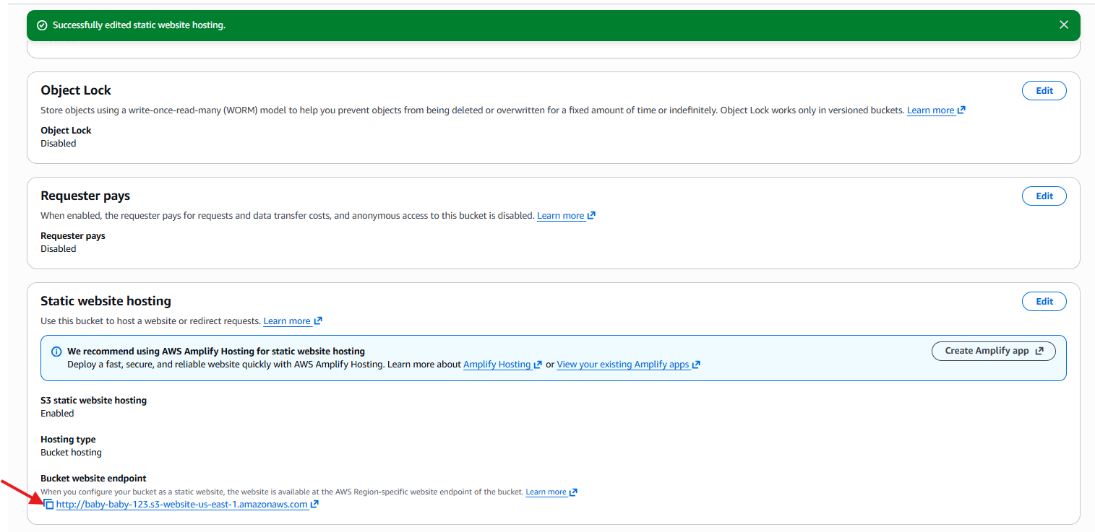

Copy the URL and browse

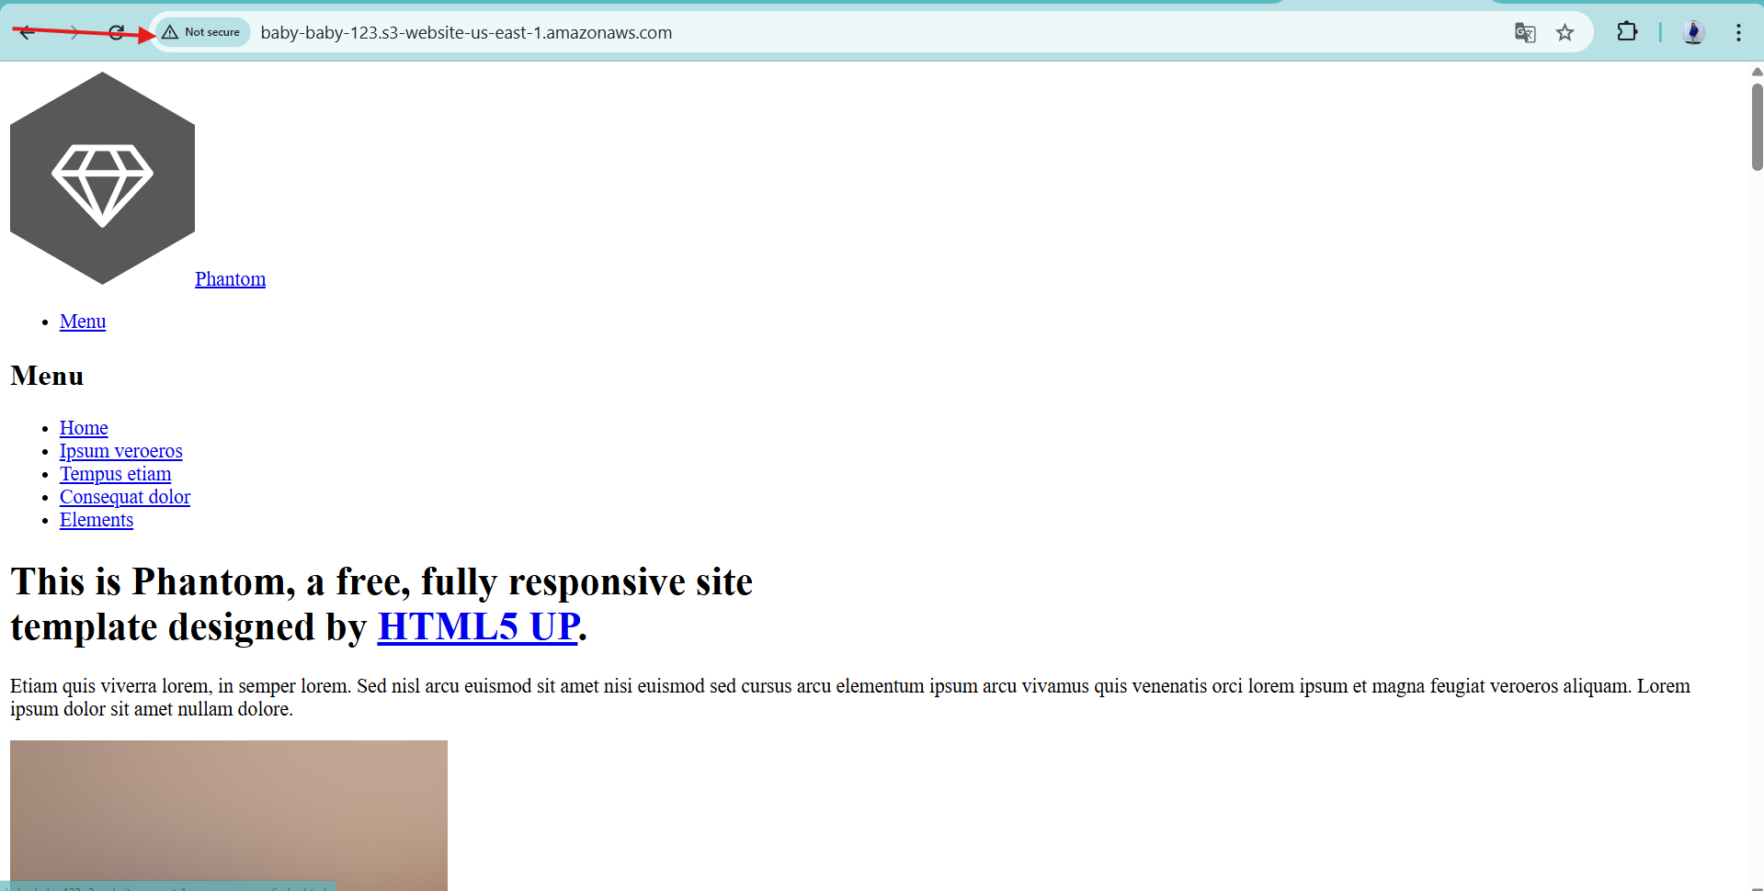

1. Enable cross-region replication on S3 buckets.

Create one buck and enable the ACLs and give the public access

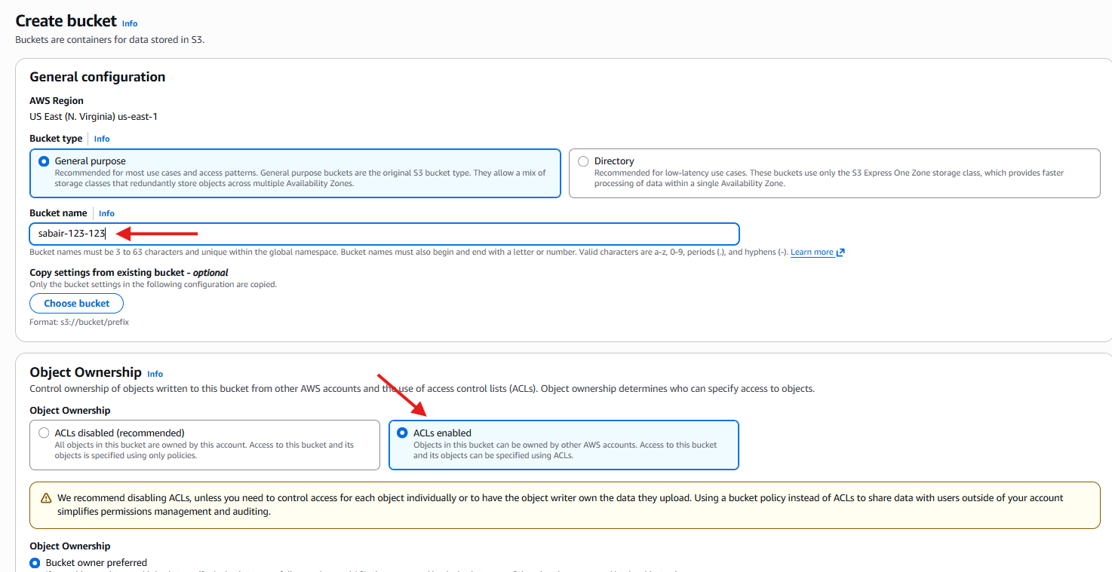

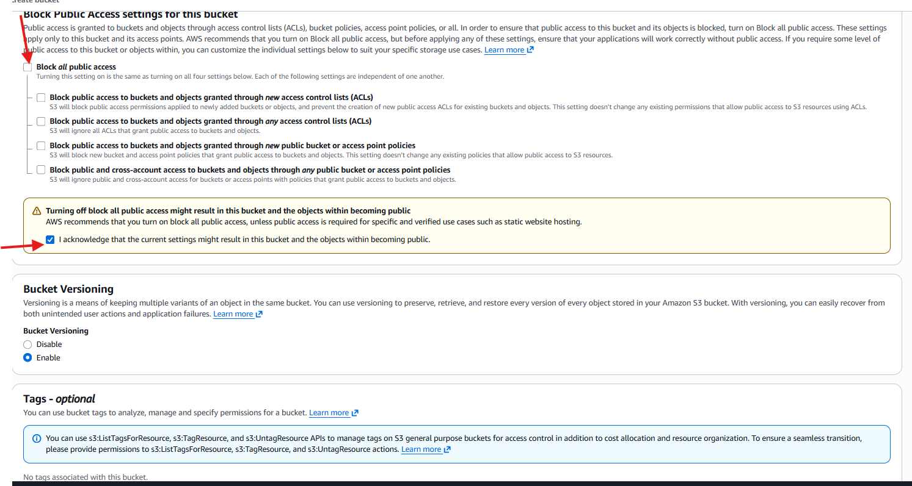

Go to the bucket versioning

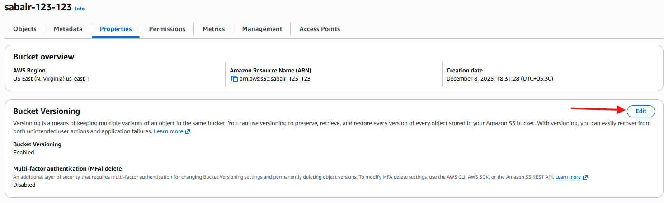

Enable the versioning and save changes

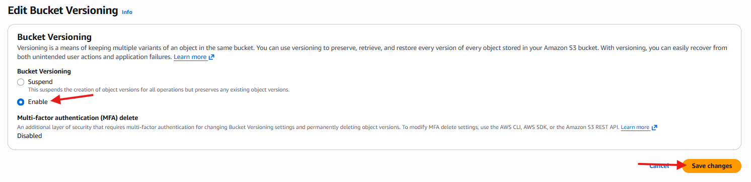

Create another bucket in another region (California)

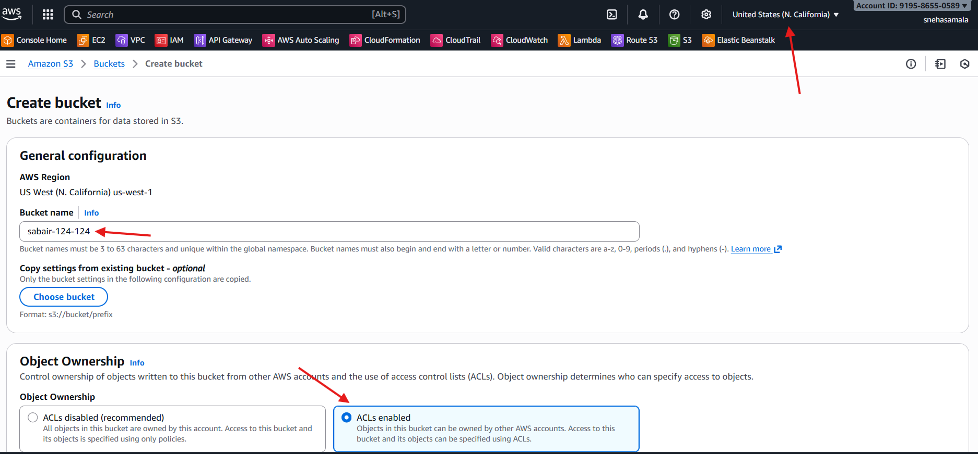

Allow all [public access

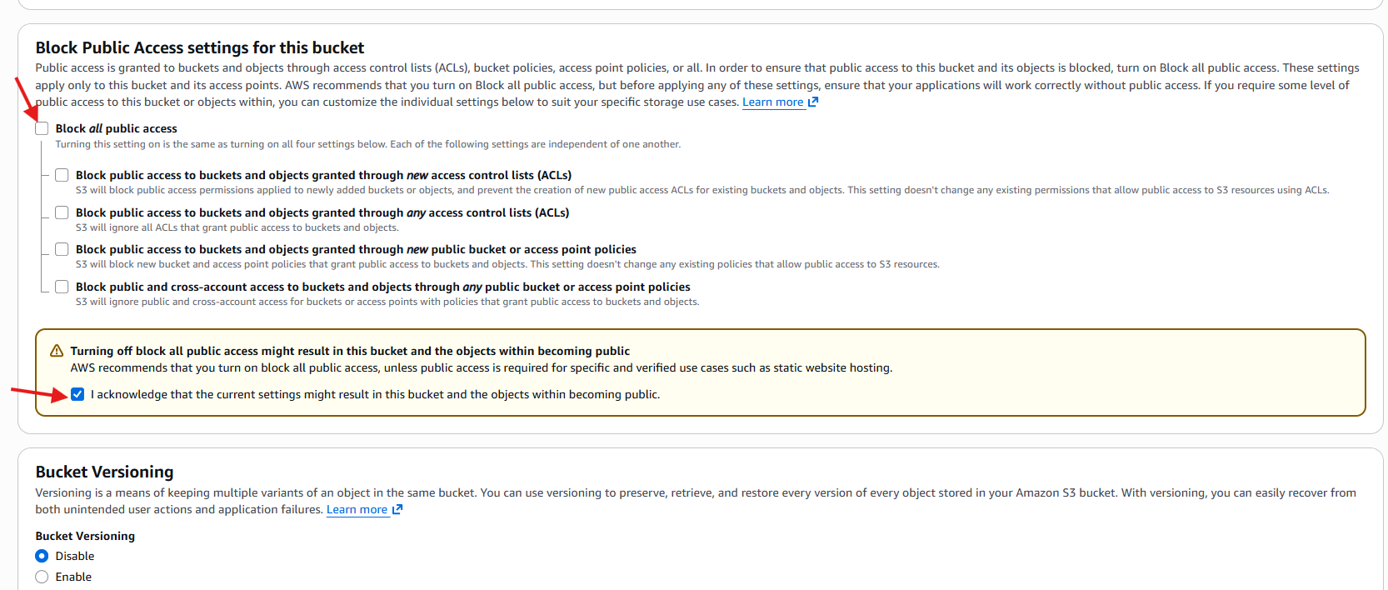

Go to the management and create the replication

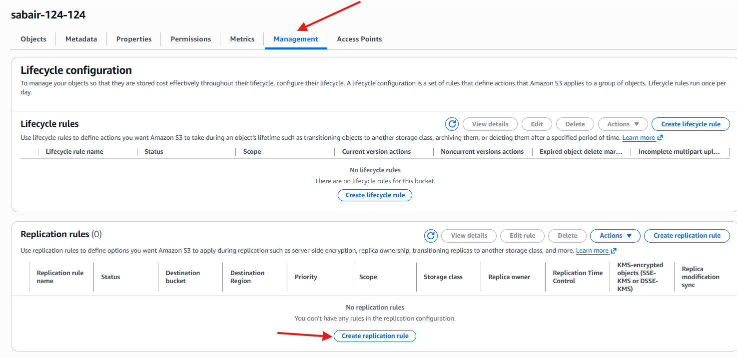

Go to the bucket versioning and edit

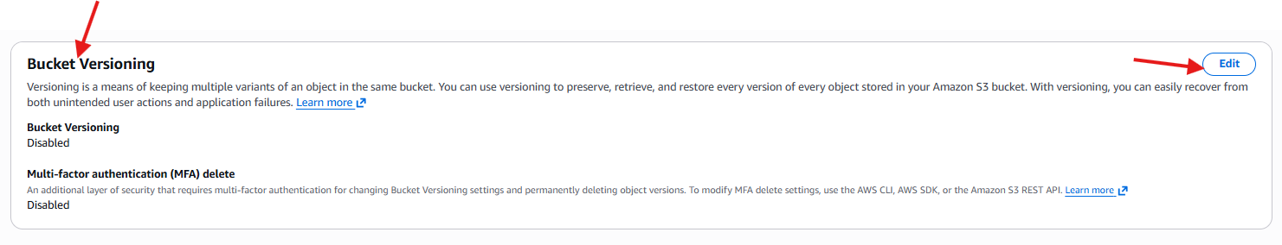

Enable the bucket

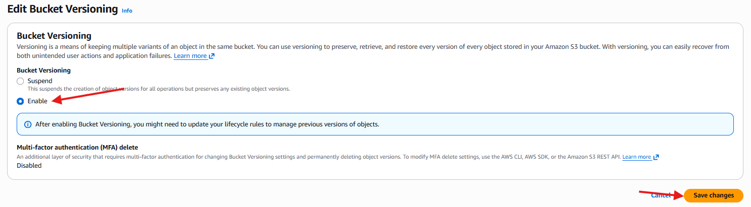

Replace the configuration

Enable 🡪 status 🡪 source🡪sabair-124-124🡪apply all the objects in the bucket

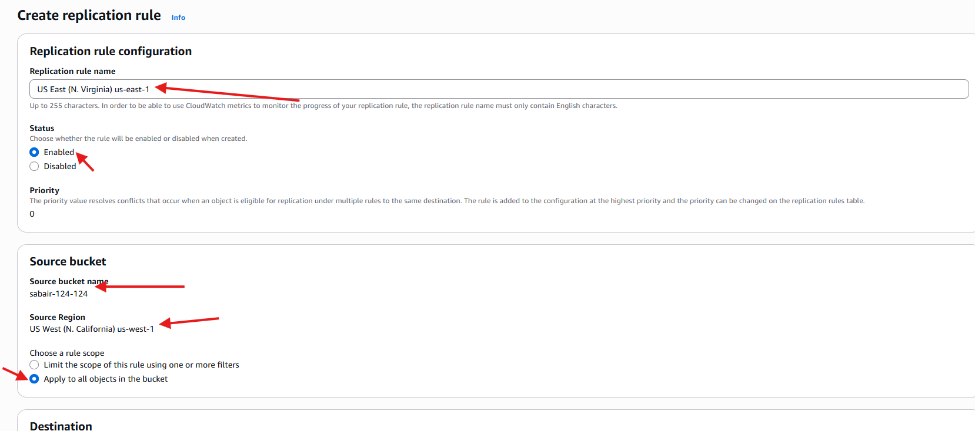

Destination🡪choose a bucket in this account

Bucket name 🡪sabair-123-123

IAM role 🡪 create new role

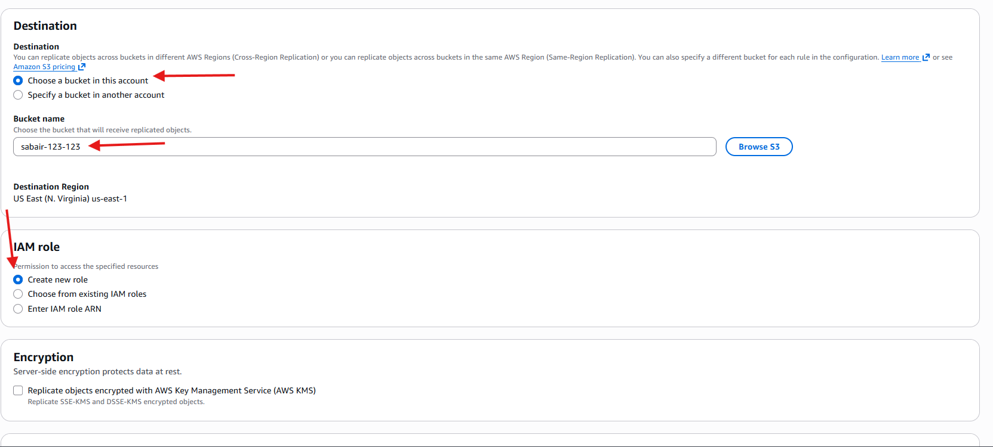

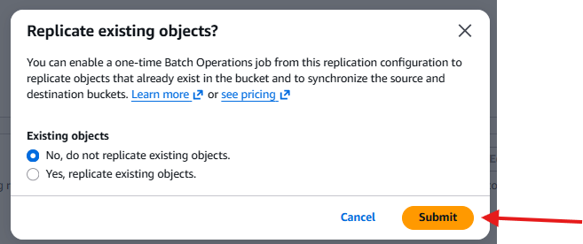

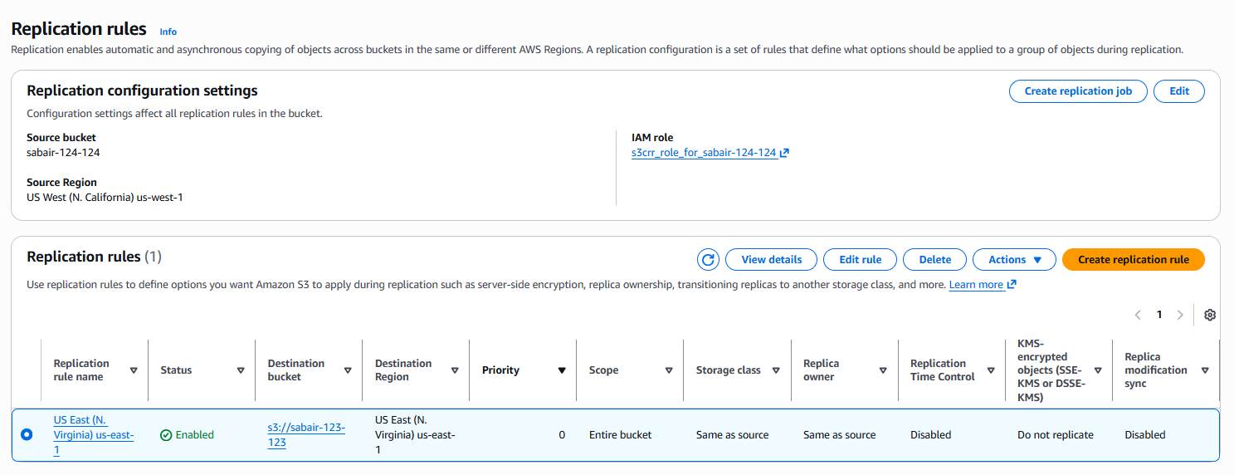

Go to the another region and select the bucket click the objects

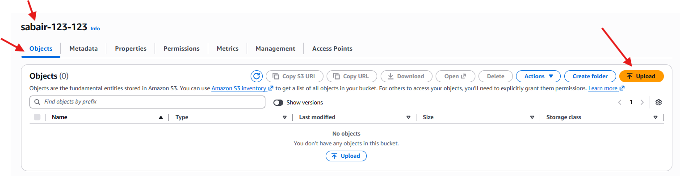

Upload the file

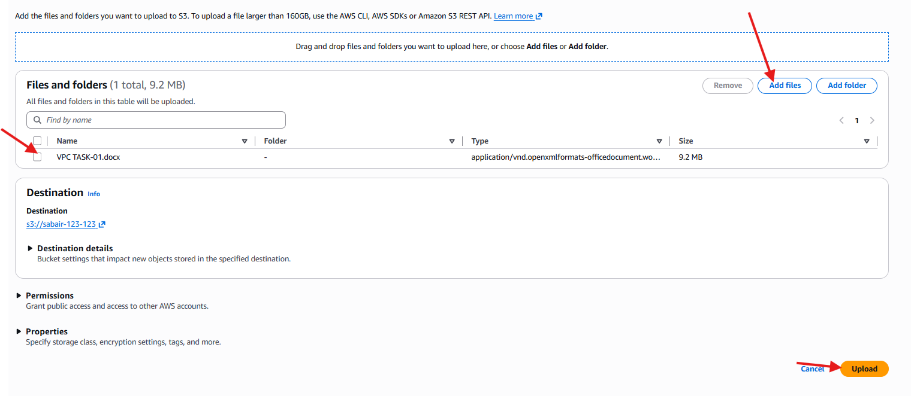

Make it public

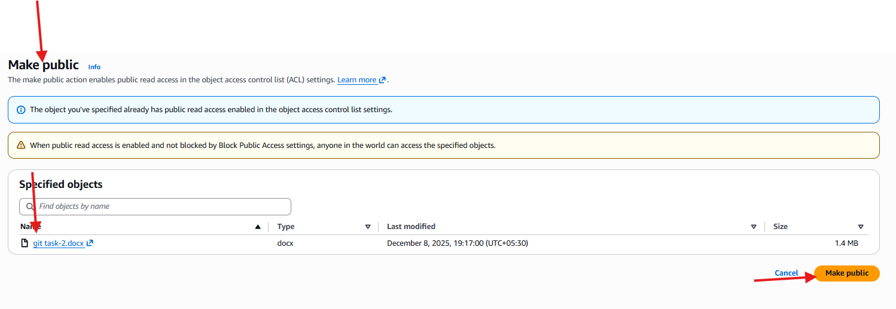

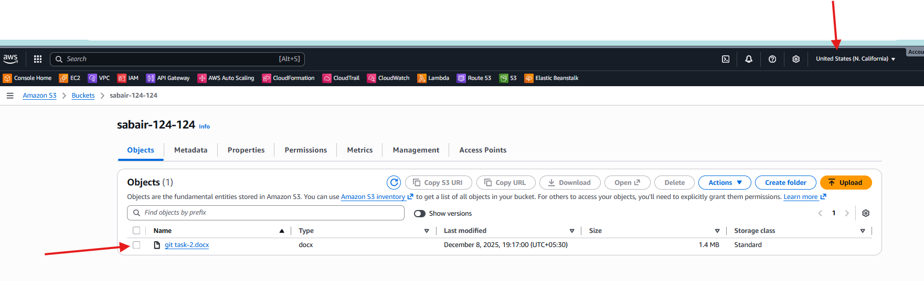

Change the region and go to the bucket and check in the object

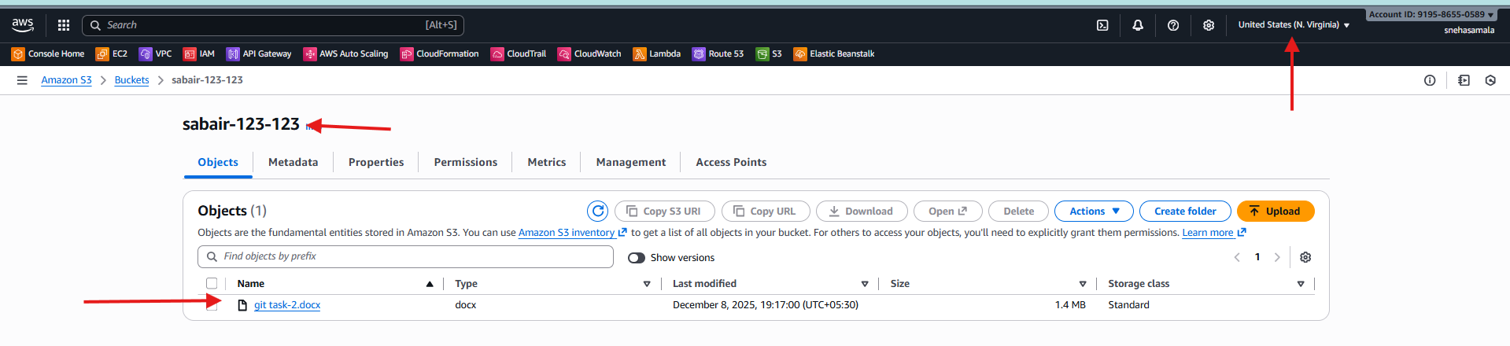

1. Configure a bucket policy so only the Admin user can see the objects of the S3 bucket.

Go to IAM and create the user and give the full access to the s3 bucket

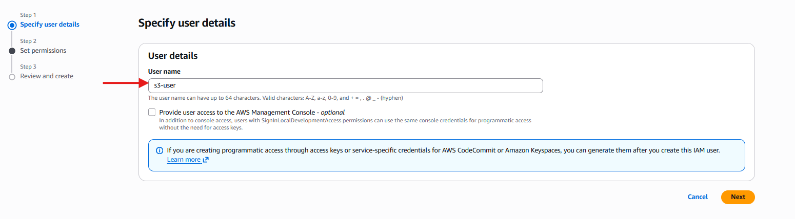

Change the policiey

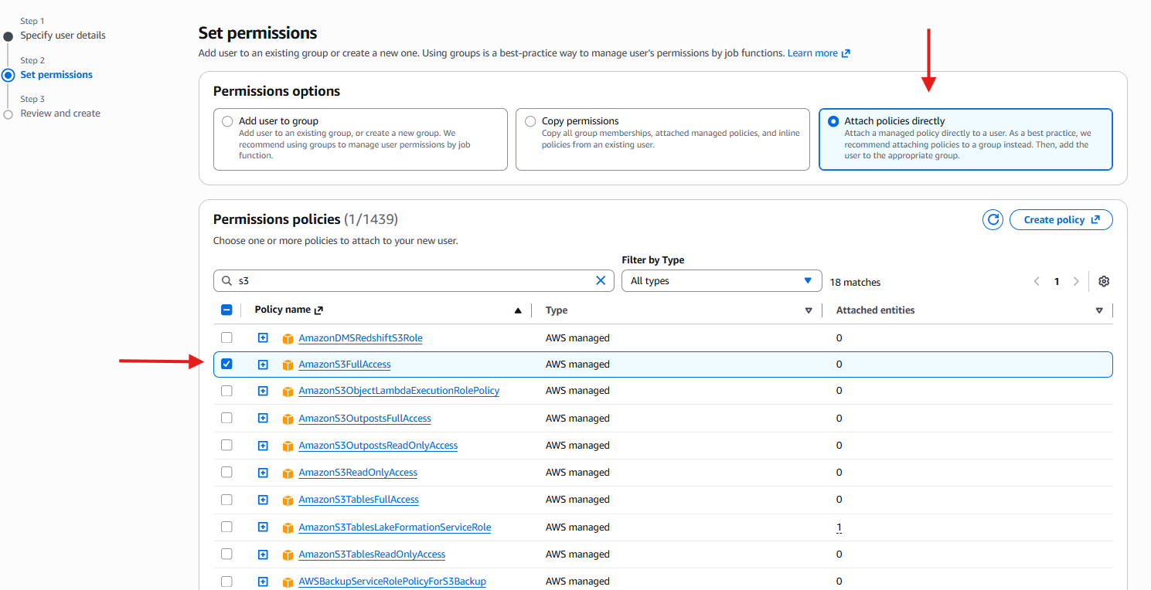

Successfully access is got

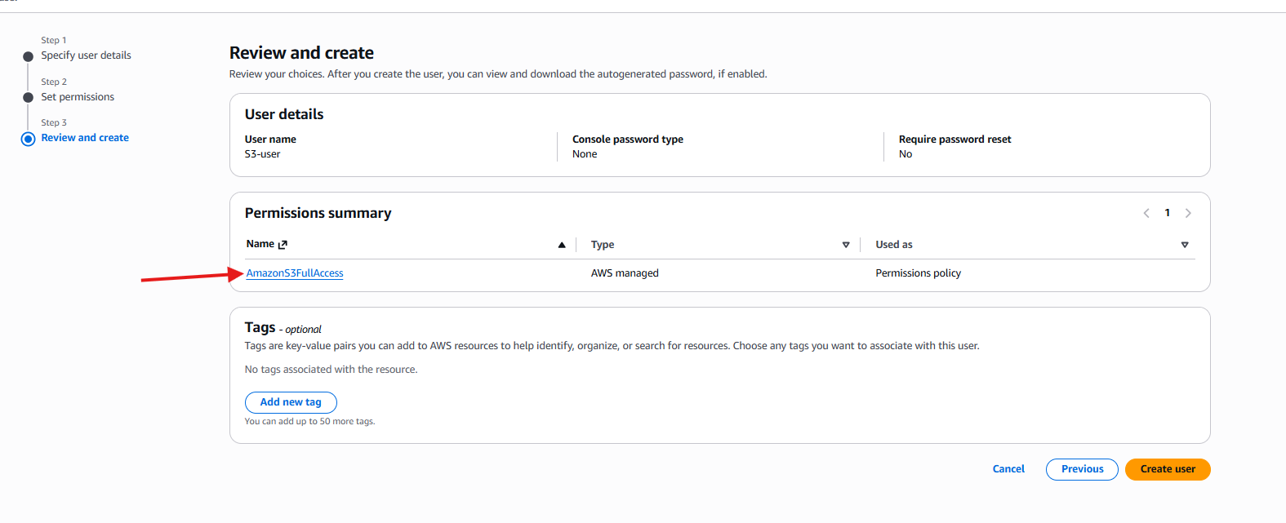

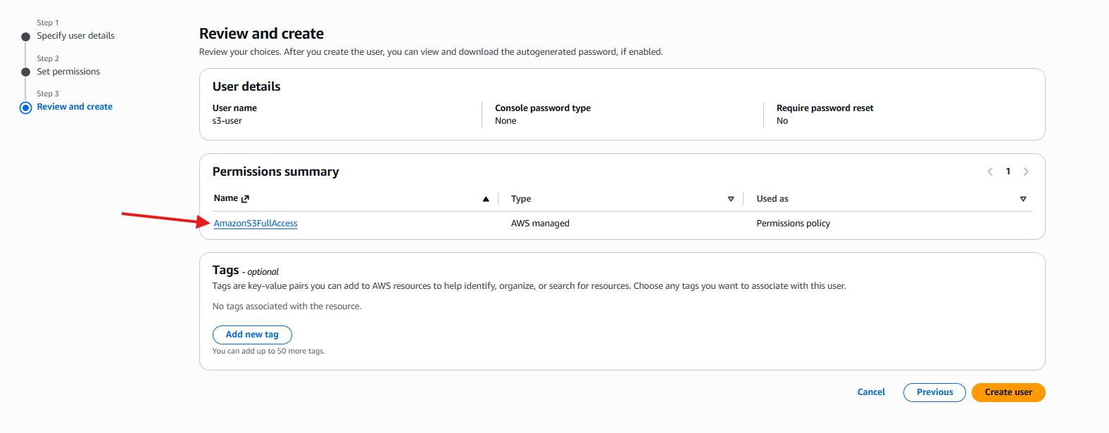

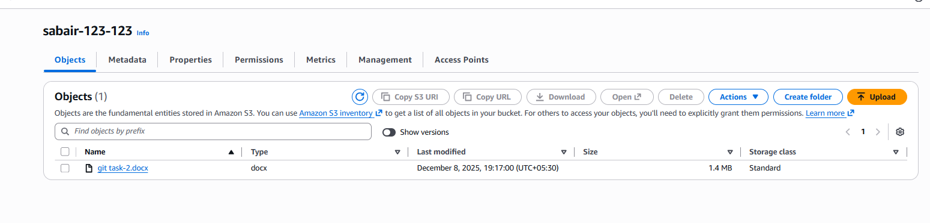

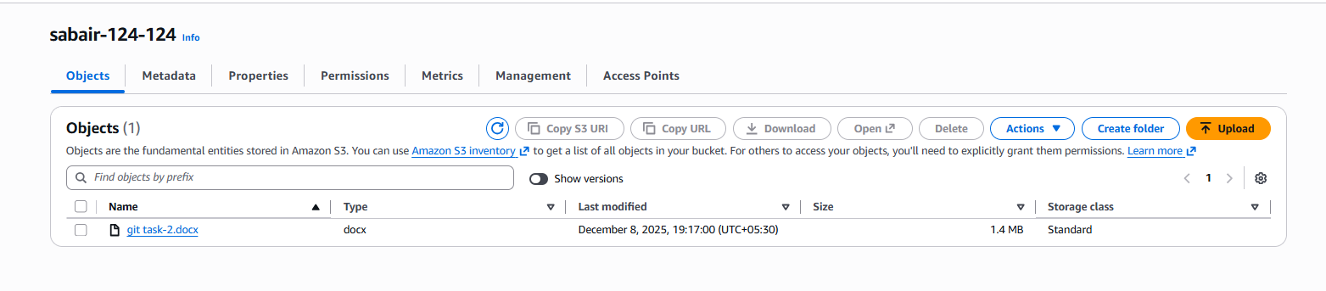

Go to the permissions and bucket policy

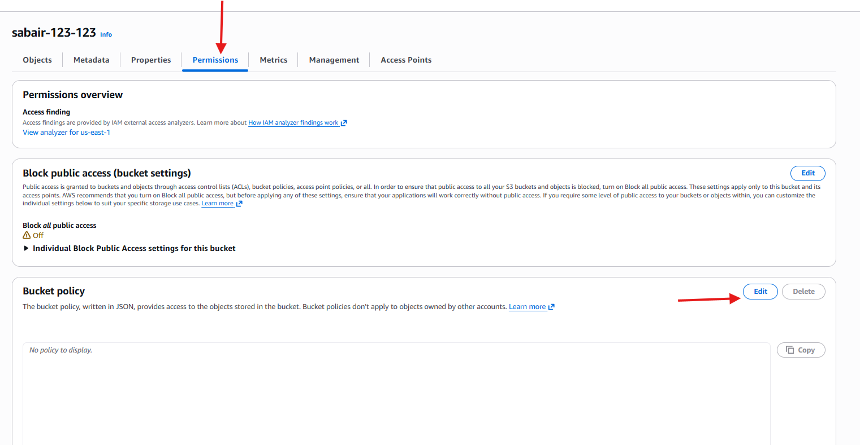

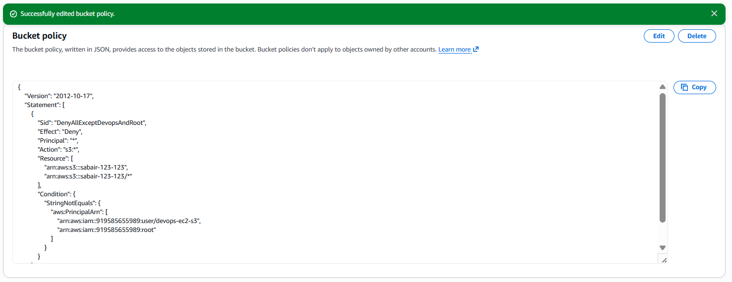

1. Set up lifecycle policies to automatically transition or delete objects based on specific criteria.

Go to the bucket and management 🡪create life cycle

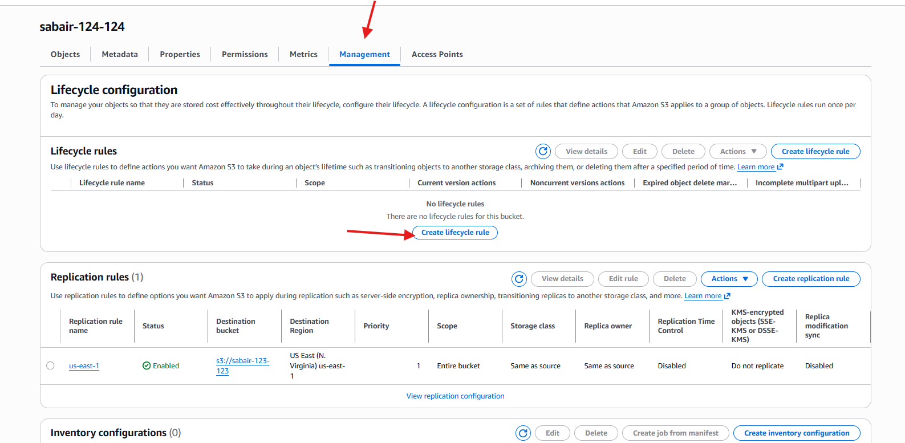

LIFEcycele🡪apply to all objects🡪enable and delete🡪

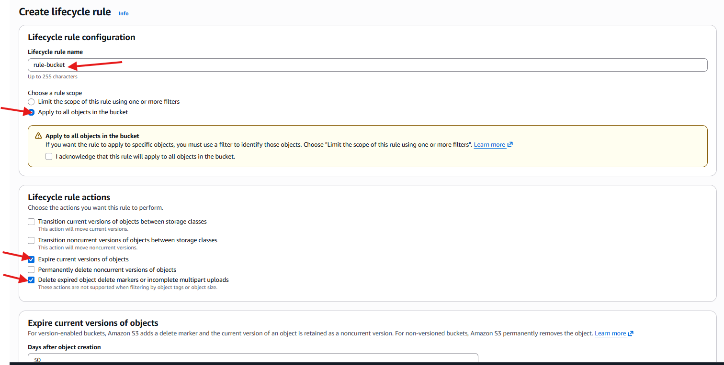

Expires in 30 days

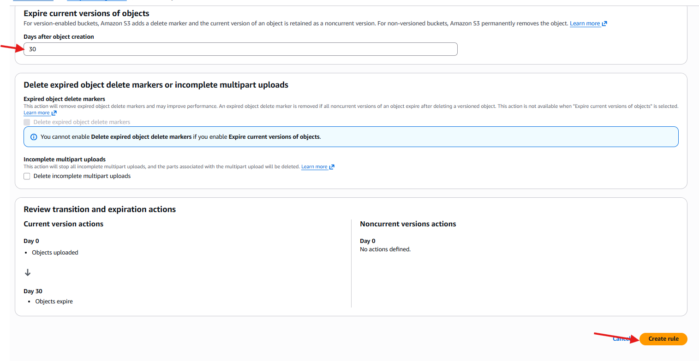

Successfully life cycle configuration is created

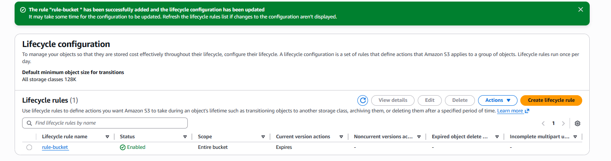

1. Push some objects to S3 using the AWS CLI.

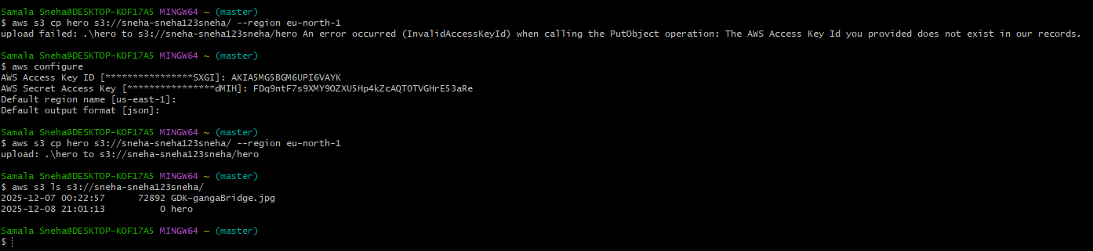

I have pushed one object to s3

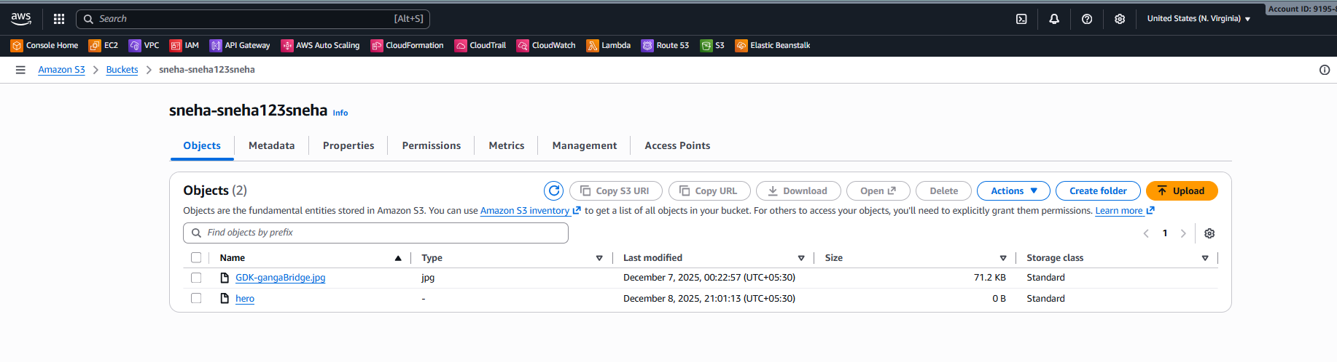

1. Write a Bash script to create an S3 bucket.

Creating the script to create the buket

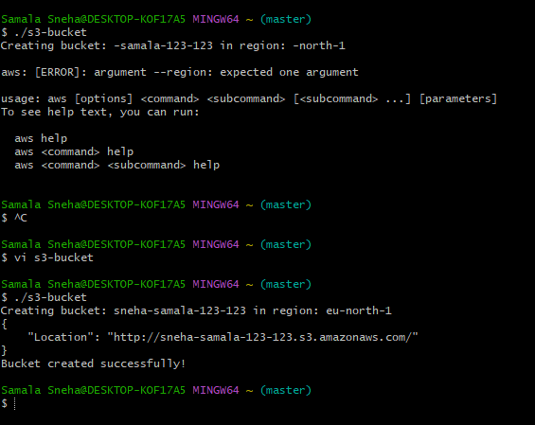

Success fully bucket is created

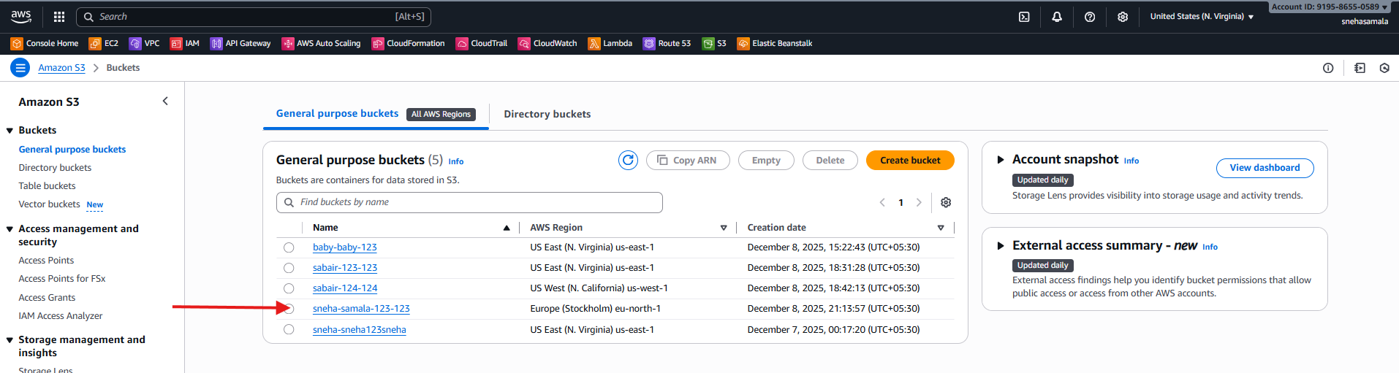

1. Upload a 1 GB file to S3 using the CLI.

Uploaded the 1gb file in CLI

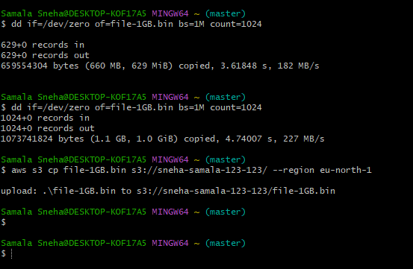

Successfully file is uploaded

